**Chapter-3**

**SOFTWARE DESIGN**

After the complete analysis of software requirements, software designing is an important part in the development phase. We have done immense storming to develop such a design which can justify all the requirements analyzed.

Our sole purpose during designing was to keep the system less complex and user friendly so that in later stages of development we can adjust by the forthcoming or unseen requirements and reduce the risk of failure at later stage development.

**3.1 DATA FLOW DIAGRAM**

Data flow diagrams (DFDs) reveal relationships among and between the various components in a program or system. DFDs are an important technique for modeling a system’s high-level detail by showing how input data is transformed to output results through a sequence of functional transformations. DFDs consist of four major components: entities, processes, data stores, and data flows. The symbols used to depict how these components interact in a system are simple and easy to understand; however, there are several DFD models to work from, each having its own symbology. DFD syntax does remain constant by using simple verb and noun constructs. Such a syntactical relationship of DFDs makes them ideal for object-oriented analysis and parsing functional specifications into precise DFDs for the systems analyst.

DFDs help system designers and others during initial analysis stages visualize a current system or one that may be necessary to meet new requirements. Systems analysts prefer working with DFDs, particularly when they require a clear understanding of the boundary between existing systems and postulated systems.

The following zero level DFD gives very good picture of the interaction between different users and the system. As it can be seen that the administrator is responsible for the complete management of the system while other users like student can practice coding and see their own performance.

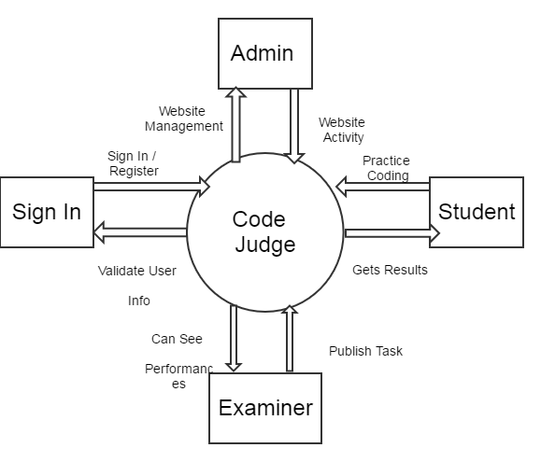

Fig. 3.1: DFD Level 0

The system itself is capable to validate the users at the time of signing in and if the user is Teacher/Examiner then he is given the liberty to create new tests and publish them as well as assesss the performance of the candidates.

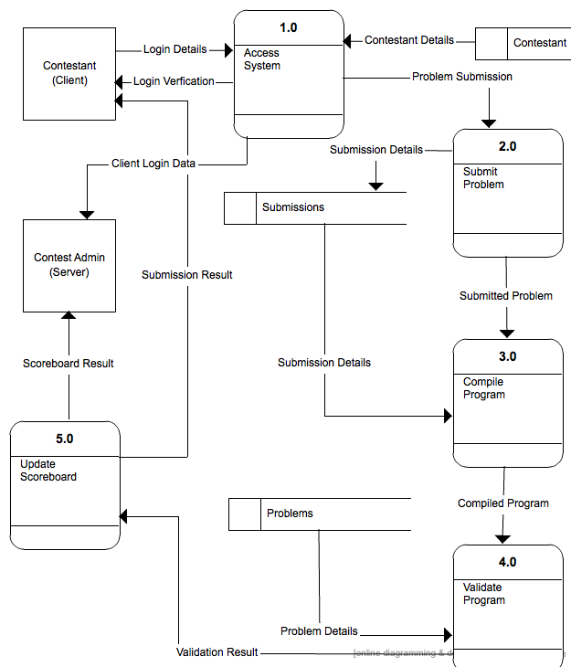

Fig. 3.2 : DFD Level 1